VS Code

How to Create a file, write code and execute the code to see the output

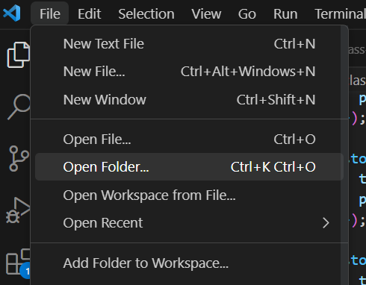

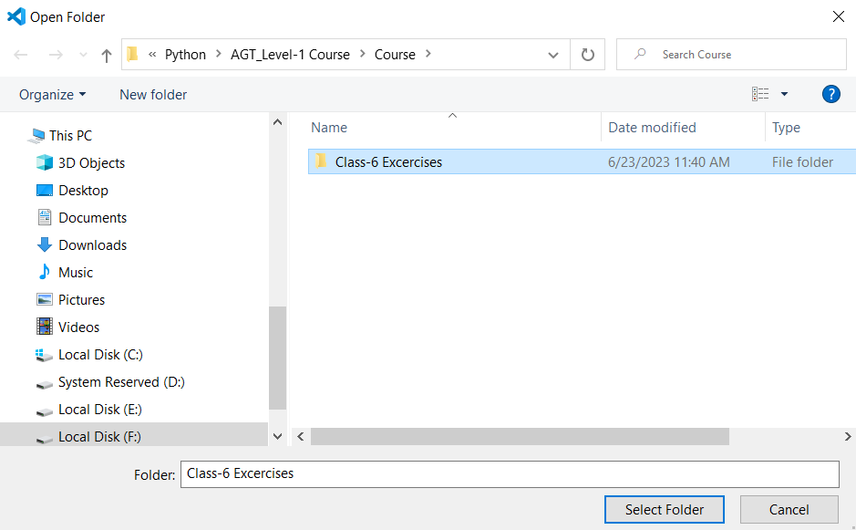

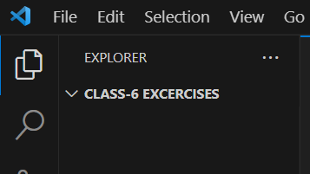



Click On First + Sign

Enter file name 1.py

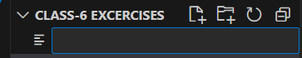

Now copy first program and paste in code window on right side

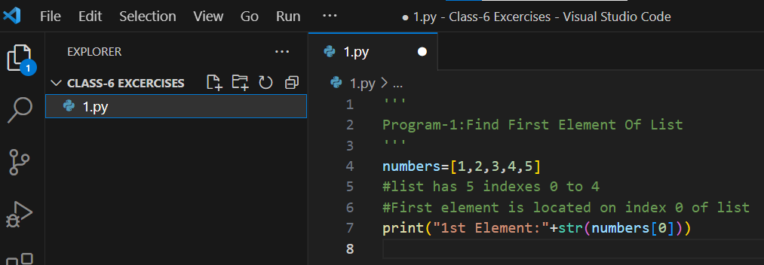

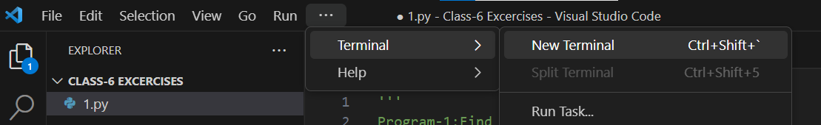

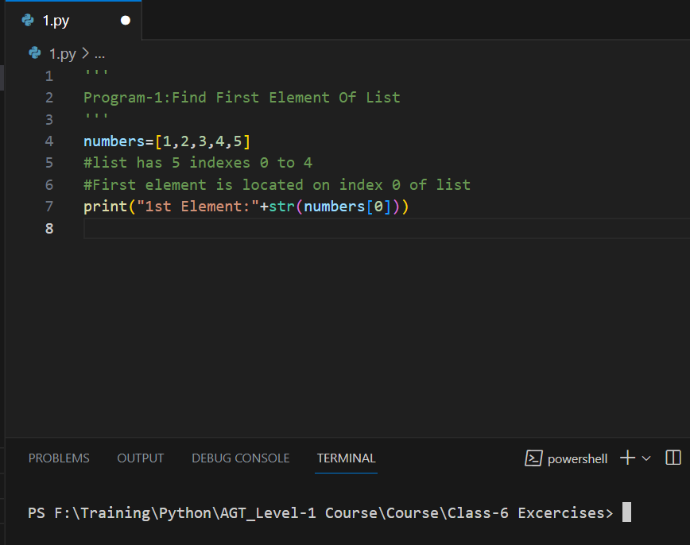

This is CLI(Command Line Interface)

Now write command

python 1.py

And hit enter

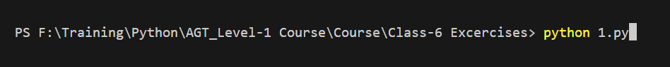



You will see the output.

This is how you create file, enter code and save and execute the code to see output.

'''

Program-1:Find First Element Of List

'''

numbers=[1,2,3,4,5]

#list has 5 indexes 0 to 4

#First element is located on index 0 of list

print("1st Element:"+str(numbers[0]))

'''

Program-2:Find Last Element Of List Method-1

'''

numbers=[1,2,3,4,5]

print("Last Element:"+str(numbers[4]))

'''

Program-3:Find Last Element Of List Method-2

'''

numbers=[1,2,3,4,50]

#first calculate the length of list and subtract from 1

length_of_list=len(numbers) #len() will return length of list which is 5

#we have to subtract it by 1 to find last element 5-1=4=numbers[length_of_list-1]=numbers[5-1]=numbers[4]=5

print("1st Element:"+str(numbers[length_of_list-1]))

'''

Program-4:Find 3rd element of list

'''

numbers=[10,20,30,40,50]

print("3rd element is "+str(numbers[2]))

'''

Program-5:

Lists Are Mutable, it means we can change list elements after creation

'''

#Change the 4th element to 100

numbers=[10,20,30,40,50]

print(numbers)

numbers[4]=100

print(numbers)

#Replace 30 with 200

numbers=[10,20,30,40,50]

numbers[2]=200

print(numbers)